|  |
| --- |
| Edinburgh Napier University |
| SET10101 – Software Architecture Coursework Testing |
| Michael Suttie - 40541559 |

|  |
| --- |
| Michael Suttie  11-29-2022 |

Table of Contents

HQ Operator Testing 3

Test Case 1 – Patient submission (Expected) 3

Test Case 2 – Patient submission (Unexpected) 3

Test Case 3 – Patient Lookup (Expected) 4

Test Case 4 – Patient Lookup (Unexpected) 4

Test Case 5 – Patient Lookup (Unexpected) 5

Test Case 6 – Request Ambulance (Expected) 6

Test Case 7 – Request Ambulance (Unexpected) 6

Ambulance Testing 7

Test Case 1 – Lookup Incident (Expected) 7

Test Case 2 – Lookup Incident (Unexpected) 7

Test Case 3 – Lookup Incident (Unexpected) 7

Test Case 4 – Update Hospital (Expected) 8

Hospital Testing 9

Test Case 1 – Update Patient 9

Test Case 2 – Delete Patient (Unexpected) 9

Test Case 3 – Delete Incident 9

Test Case 3 – Delete Patient (Expected) 10

# HQ Operator Testing

### Test Case 1 – Patient submission (Expected)

**Input:** Jane, Doe, 54345, Chestnut Road, Midlothian, Heart Disease

**Expected Result**: Success Message and database insersion .

**Result:**

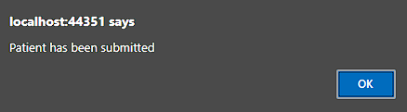

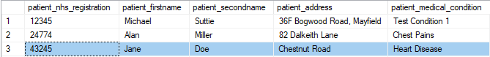

### Test Case 2 – Patient submission (Unexpected)

**Input:** N/A

**Expected Result**: Error Message

**Result:**

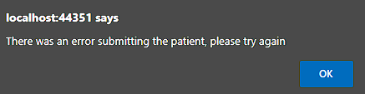

### Test Case 3 – Patient Lookup (Expected)

**Input:** 54345

**Expected Result**: Success Message and form filled

**Result:**

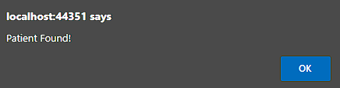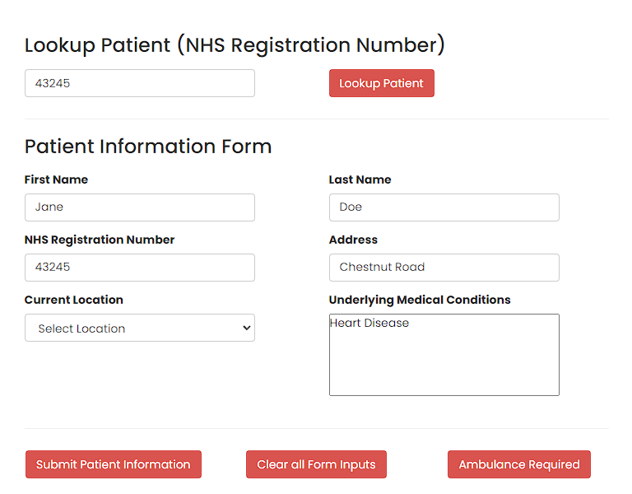

### Test Case 4 – Patient Lookup (Unexpected)

**Input:** N/A

**Expected Result**: Error Message

**Result:**

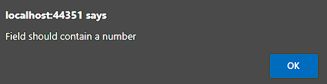

### Test Case 5 – Patient Lookup (Unexpected)

**Input:** 11211 (Does not exits)

**Expected Result**: Patient not found message

**Result:**

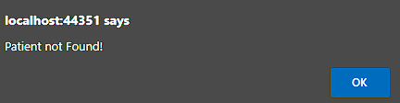

### Test Case 6 – Request Ambulance (Expected)

**Input:** Midlothian, Midlothian Community Hospital (Valid location and hospital)

**Expected Result**: Success message, ID shown and insertion into database

**Result:**

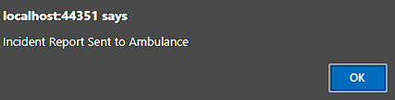





### Test Case 7 – Request Ambulance (Unexpected)

**Input:** Request an Ambulance for a patient not in the system

**Expected Result**: Error Message

**Result:**

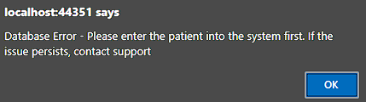

# Ambulance Testing

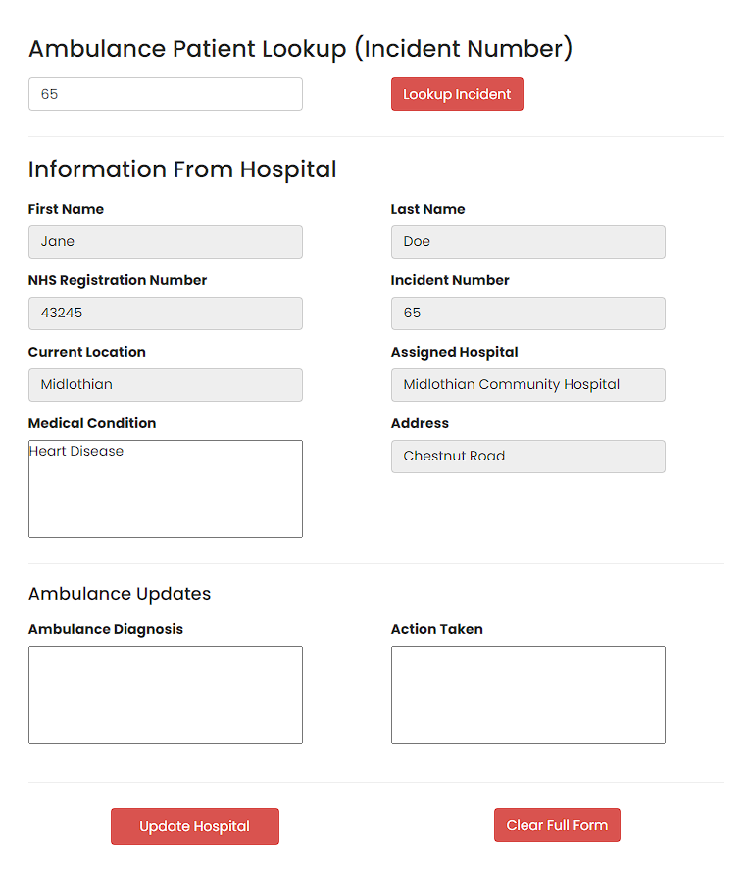

### Test Case 1 – Lookup Incident (Expected)

**Input:** 65 (Valid incident number)

**Expected Result**: Success message, form populated

**Result:**

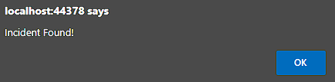

### Test Case 2 – Lookup Incident (Unexpected)

**Input:** N/A (Invalid incident number)

**Expected Result**: Success message, form populated

**Result:**

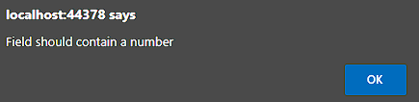

### Test Case 3 – Lookup Incident (Unexpected)

**Input:** 802 (Non existing incident number)

**Expected Result**: Success message, form populated

**Result:**

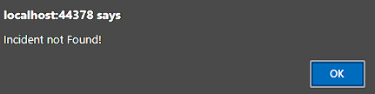

### Test Case 4 – Update Hospital (Expected)

**Input:** Heart Attack, Blood thinners

**Expected Result**: Success message, Hospital updated and callout time calculated. Inserted into database

**Result:**

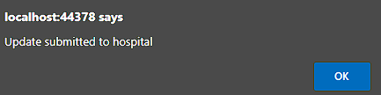



# Hospital Testing

### Test Case 1 – Update Patient

**Input:** Mark, Smith, Apple Lane, Citrus Allergy

**Expected Result**: Success message, Patient record updated

**Result:**

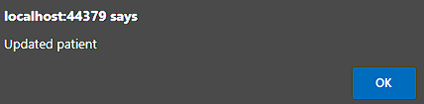





### Test Case 2 – Delete Patient (Unexpected)

**Input:** Deletion of a patient with existing incidents

**Expected Result**: Error message

**Result:**

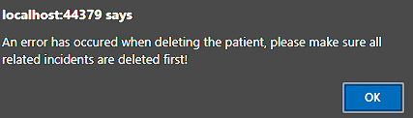

### Test Case 3 – Delete Incident

**Input:** Deletion Jane Doe (Now Mark Smiths) incident (number 65)

**Expected Result**: Success message and removed from database

**Result:**

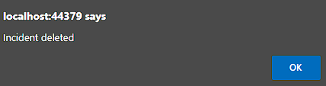

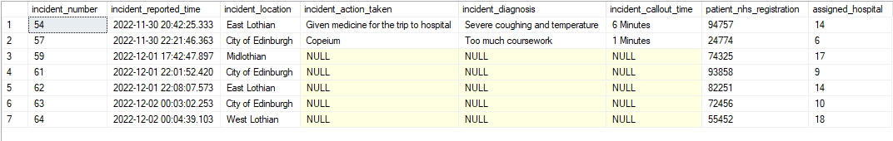

### Test Case 3 – Delete Patient (Expected)

**Input:** Deletion Jane Doe (Now Mark Smiths)

**Expected Result**: Success message and removed from database

**Result:**

